

**Group members:**

|  |  |
| --- | --- |
| Student1276643 | MUHAMMAD HAMZA |
| Student1297252 | SYED MUHAMMAD SHAHZAIB ALI |
| Student1289573 | SYED SHAHRUKH AHMED |
| Student1296571 | MUHAMMAD KHAN |

**Faculty/Coordinator:**

|  |
| --- |
| * Miss Rubaisha Javed (Teacher) |
| * Miss Safia Maqsood (Coordinator) |

**Batch CODE:** 2101B1

**About Page**

**Log in Button**



cv

**Home Page: Active**

**Logo**

**Contact page**

**Services page which contains mask SMS, non-masking SMS, etc.**

**Home Page contains short highlights about the following:**

* Our Features
* Our Offers

* Clients Feedback

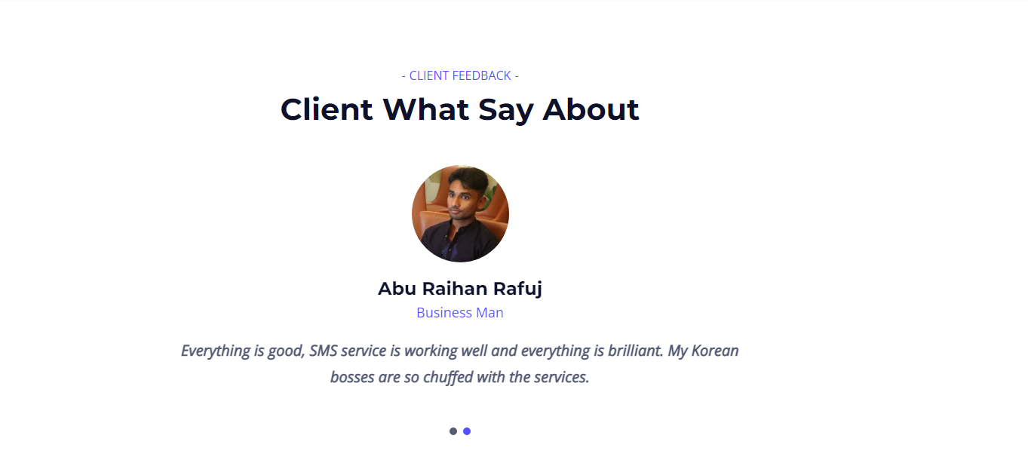

* 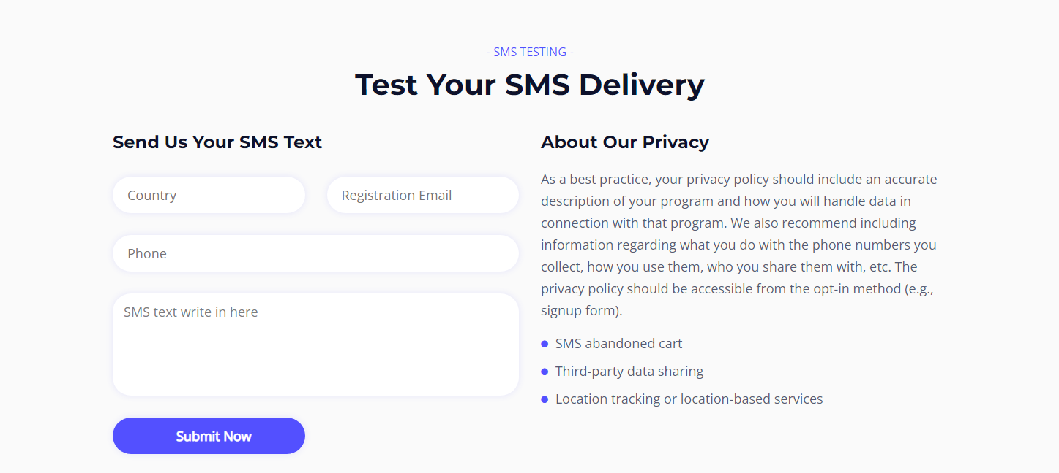SMS Testing

**DASHBOARD:**

